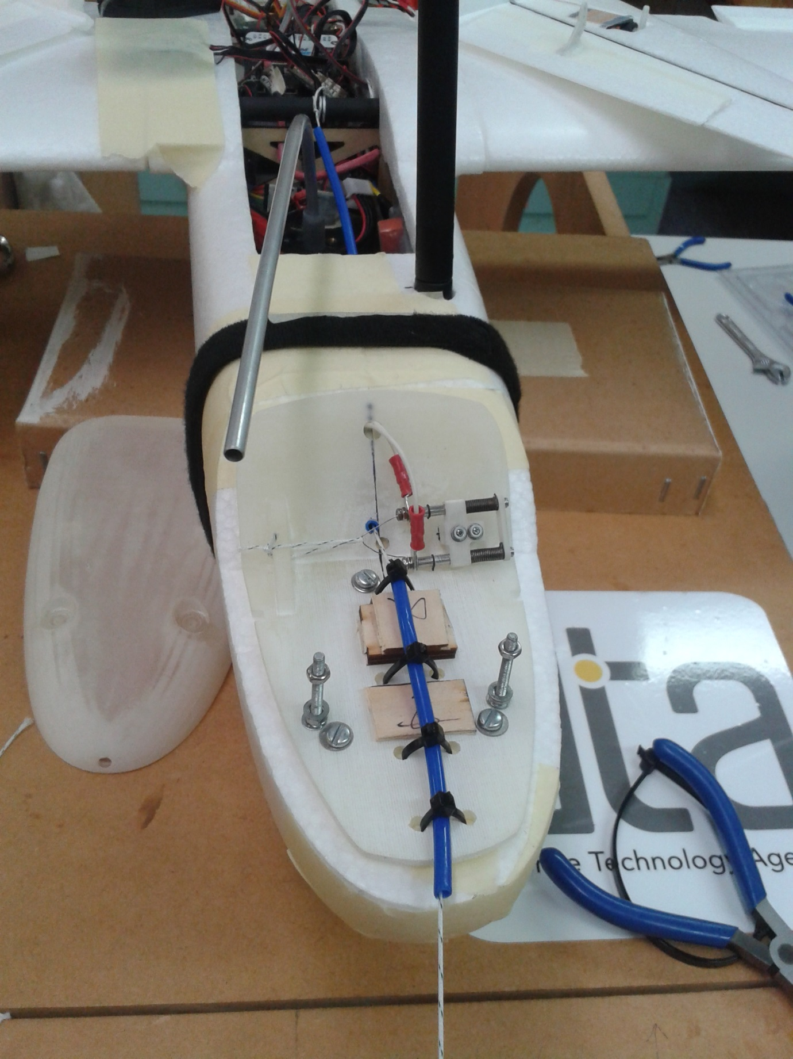

Hot wire is held away from the main line (to avoid chaffing) by a retaining line. When hot wire is on it cuts the retaining line first and then allows the hot wire to cut the main tether. Hot wire is currently switched on for 15 seconds to ensure cut through of main line. Testing in cold chamber at -30C has shown this works.

Hot wire cutter: Line passes through the cutting loop of the hot wire. Hot wire is spring loaded to pull perpendicular to the main line to ensure it cuts

Line is attached to the airframe via the main carbon tube spar (carries load of wings into the fuselage)

Line runs through plastic tubes for protection and location

Tether 50 lb (220 N) breaking strain dacron line attached to balloon